Mindfulness activities for children

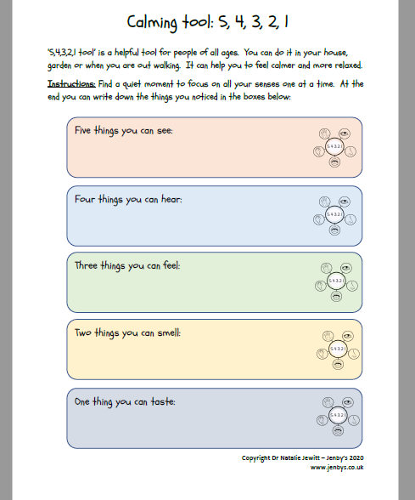
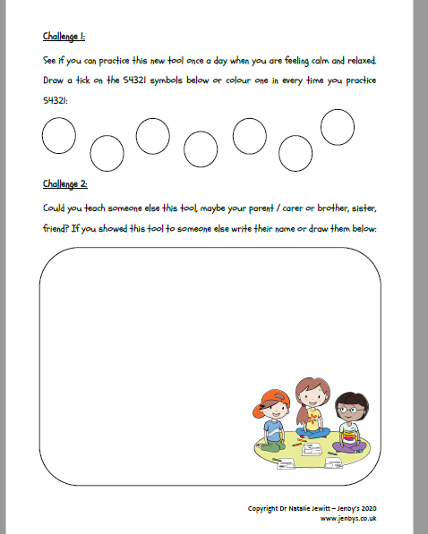

Please find this free Resource at- https://www.jenbys.co.uk/media/lheolpzk/jenby-s-54321-tool.pdf

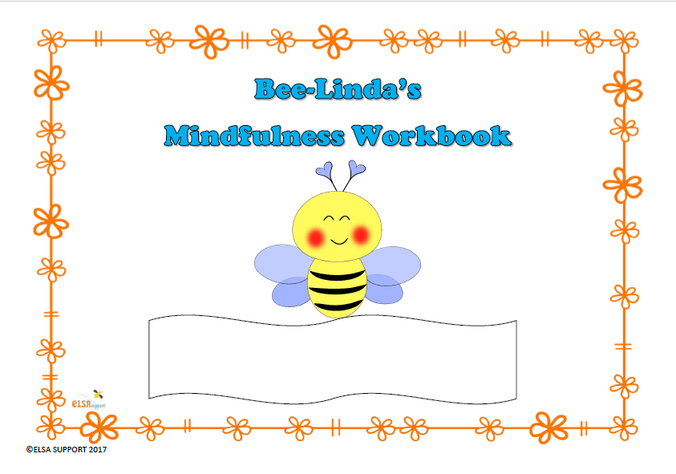

Please find this resource at- https://www.elsa-support.co.uk/downloads/bee-lindas-mindfulness-workbook-item-180/

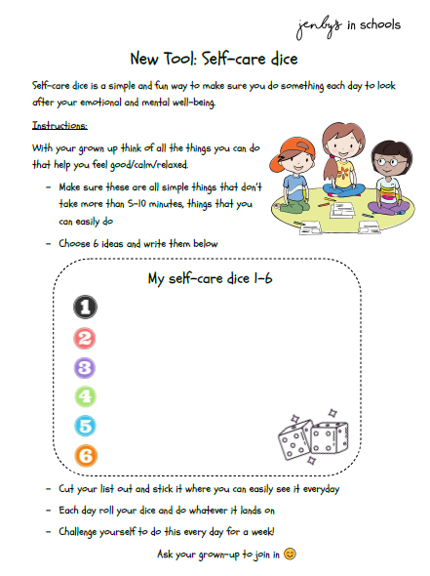

Please find this free resource at- https://www.jenbys.co.uk/media/kjrfvtqk/jenby-s-in-schools-selfcaredice-tool.pdf

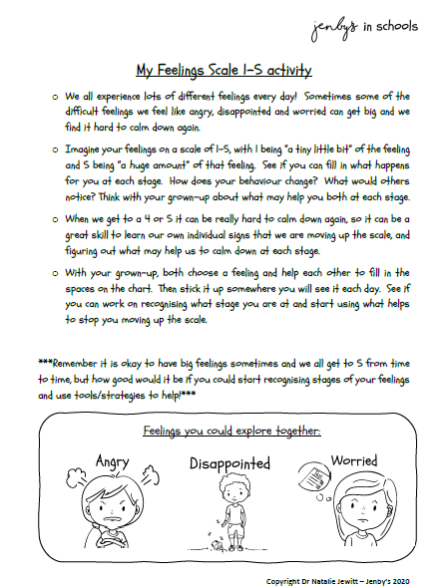

Please find this free resource at- https://www.jenbys.co.uk/media/cv3lxj4n/jenby-s-my-feelings-scale-activity.pdf

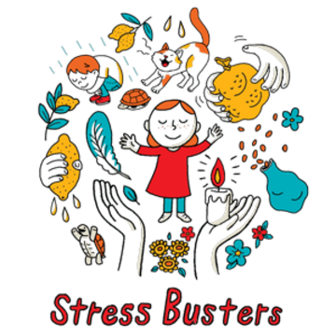

Please find this Free resource at - https://www.savethechildren.org/us/what-we-do/emergency-response/coronavirus-outbreak/resources/easy-at-home-relaxation-activities-to-help-calm-kids

Mindful colouring activities, printable resources.

https://www.jenbys.co.uk/media/oyjawpl3/jenby-s-mindful-colouring-page-1-dog.pdf
https://www.jenbys.co.uk/media/lbnb0qpl/jenby-s-mindful-colouring-page-2-cat.pdf
https://www.jenbys.co.uk/media/1nyjqs2h/jenby-s-mindful-colouring-page-3-chameleon.pdf
https://www.jenbys.co.uk/media/jlzpcejm/jenby-s-mindful-colouring-page-4-unicorn.pdf
https://www.jenbys.co.uk/media/a4fbgjm5/jenby-s-mindful-colouring-page-5-panda.pdf
https://www.elsa-support.co.uk/downloads/bee-linda-bee-mindfulness-colouring-book-item-373/

