Covid19 social story
What is Coronavirus?

Version 1

Version 2

Version 3

Covid19 social story
What is Coronavirus?

Version 1

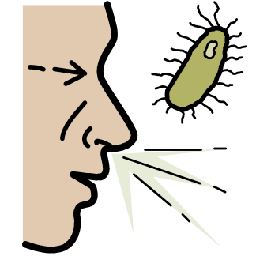
What is Coronavirus?

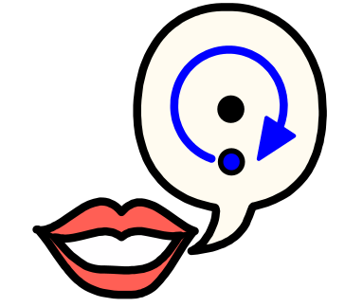
Lots of people are talking about Coronavirus.

Sometimes people call Coronavirus Covid-19.

Covid-19 and Coronavirus are the same thing.

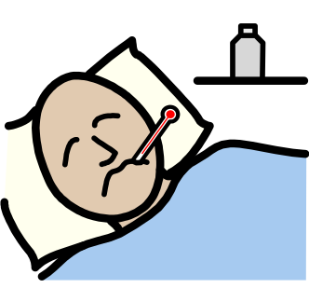
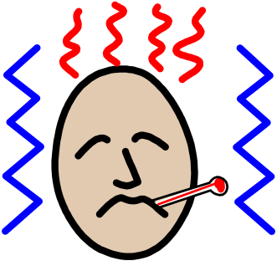
Coronavirus can make people feel unwell like having the flu or a

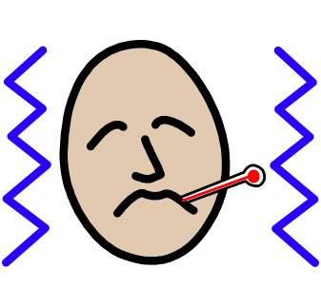
very bad cold.

Some people get Coronavirus and don't know because they feel ok.

Some people get Coronavirus and become a little bit unwell.

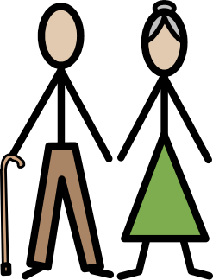
Coronavirus can make some people who are older than 60 very

unwell.

Coronavirus can make some people who are already unwell very

unwell.

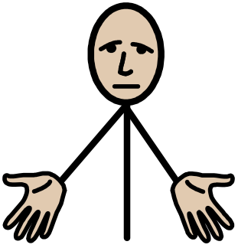
If someone becomes very unwell they might need to go to

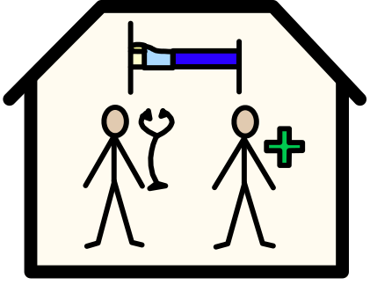
hospital.

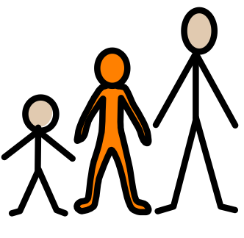
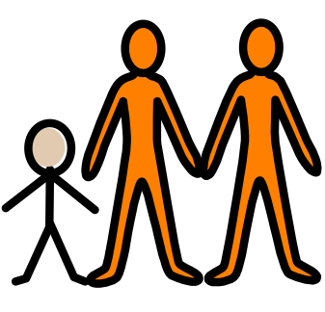
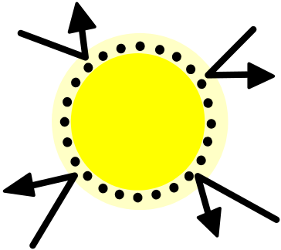
Young people and adults are good at fighting off Coronavirus.

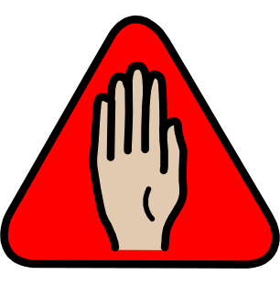
There are things that I can do to try and stop myself getting

Coronavirus.

There are things I can do to help stop Coronavirus spreading.

I will try to help stop Coronavirus spreading.

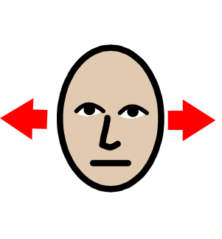
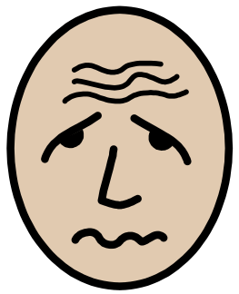
I don’t need to be worried about Coronavirus.

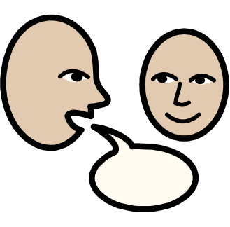
If I feel worried I can talk to the adults who look after me.

Covid19 social story
What is Coronavirus?

Version 2

What is Coronavirus?

Lots of people are talking about Coronavirus.

Sometimes people call Coronavirus Covid-19.

Covid-19 and Coronavirus are the same thing.

Coronavirus is a kind of disease that can make you feel unwell like

having the flu or a very bad cold.

Coronavirus is spreading quite fast.

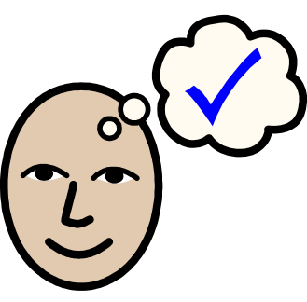
Some people have Coronavirus and don't even know because they

feel ok.

Some people who get Coronavirus become a bit unwell and then get

better.

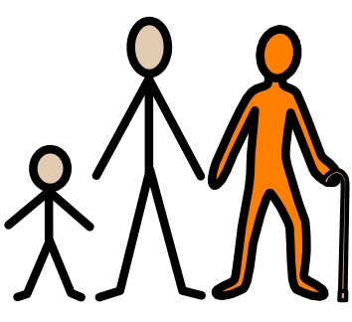
Coronavirus can make some people who are older than 60 very

unwell.

Coronavirus can make some people who are already unwell very

unwell.

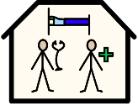
If someone becomes very unwell they might need to go to hospital.

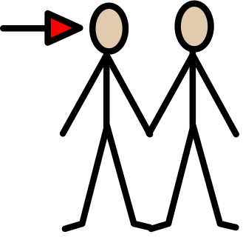
At hospital they can get special medicine to help them get

better.

Young people and adults are good at fighting off Coronavirus.

There are things that I can do to try and stop myself getting

Coronavirus.

There are things I can do to help stop Coronavirus spreading.

I will try to help stop Coronavirus spreading.

I don’t need to be worried about Coronavirus.

If I feel worried about Coronavirus I can talk to the adults

who look after me.

Covid19 social story
What is Coronavirus?

Version 3

Lots of people are talking about Coronavirus.

Sometimes people call Coronavirus Covid-19.

Covid-19 and Coronavirus are the same thing.

Coronavirus is a kind of disease that can make you feel unwell

like having the flu or a very bad cold.

Coronavirus is spreading quite fast.

This means lots of people are getting Coronavirus.

Some people have Coronavirus and don't even know because they

feel ok.

Some people who get Coronavirus become a bit unwell and then get

better.

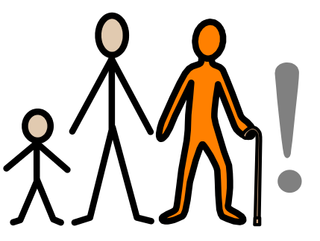
Coronavirus can make some people who are over who are over 60

very unwell.

Coronavirus can make some people who are already unwell very

unwell.

If someone becomes very unwell they might need to go to

hospital.

At hospital they can get special medicine to help them get

better.

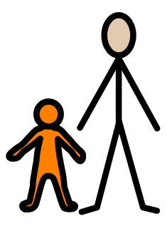
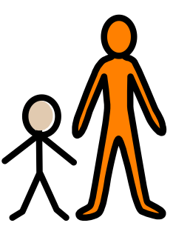
Young people and adults are good at fighting off Coronavirus.

If you don’t feel well you should tell an adult.

People who get Coronavirus get a fever.

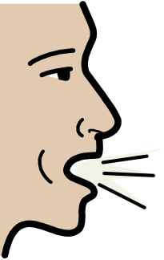
People who get Coronavirus get a cough.

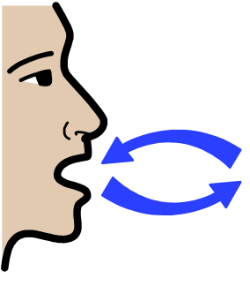
People who get Coronavirus might have difficulty breathing properly.

If you feel that you have any of these things you should tell an

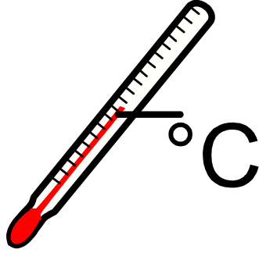
adult so they can check your temperature.

There are things that I can do to try and stop myself getting

Coronavirus.

There are things I can do to help stop Coronavirus spreading.

I will try to help stop Coronavirus spreading.

I don’t need to be worried about Coronavirus.

If I feel worried I can talk to the adults who look after me.

